TECHNICAL PROPOSAL

for the tender:
Toolbox for investigation and response to Food and Waterborne Disease Outbreaks with an EU dimension

Publication Reference: OJ/2010/02/16-PROC/2010/007

April 2010

By consortium consisting of:
Statens Serum Institut, Copenhagen, Denmark &
The Norwegian Institute of Public Health, Oslo, Norway

And with sub-contractor:
EpiData Association, Odense, Denmark
Table of Contents

Summary 2
Section I. Context of the proposal and description and competence of the tenderer 3
Background 3
Overall description of the tenderer 4
Experience in investigation and response to FWD outbreaks 4
Statens Serum Institut 5
Norwegian Institute of Public Health 6
EpiData 8
Section II. Description of tasks and proposed methodology 11
Introduction 11
Task 1 12
Task 2 13
Task 3 14
Task 4 16
Tasks 5 and 6 17
Task 7 22
Task 8 24
Task 11 30
Section III. Project management, time and evaluation procedures 32
Project group 32
Role of each participant 32
External group of professional advisors 32
Deliverables, project timeline 34
Monitoring plan, milestones 37

Summary
This technical proposal describes how the tenderer propose to develop the 11 tools for outbreaks investigations described in the tender specifications. The tenderer is a consortium consisting of scientists and public health experts with wide experience in national and European outbreak investigations from the national institutes of infectious diseases in Denmark and Norway. In addition, the scientists developing the free software EpiData are part of the application as sub-contractors. The proposal is structured into three parts according to the award criteria.
- Part I describes the tenderer, focusing on their experiences with FWD outbreaks and outlining the challenges of outbreak investigations in a European context.
- Part II contains a detailed description of the proposed solution of the 11 specified tasks, including methodology and outcome of each task.
- Part III describes how the proposed solutions will be carried out, detailing the project plan, the individual project participants and the project management scheme.

A notable feature is the proposed solution to tasks 5-8 which consists of the development of a topic specific general questionnaire bank and integrated software tools for questionnaire construction, data management and data analysis expanding on the existing and well recognised EpiData technology in a sustainable framework.

Section I. Context of the proposal and description and competence of the tenderer

Background

Historically, most foodborne outbreaks have been considered as local events, affecting a group of people who were attending the same social event or who had visited the same restaurant. These outbreaks were easy to detect and investigate, due to the clustering of cases linked to one specific setting. The changes in food habits and global trade have lead to a change in the outbreak settings, and increasingly foodborne outbreaks affecting several countries are recognized. In such outbreaks the sources that have been identified during the investigations include food products contaminated at the source or at a central food processing factory before marketing. Such outbreaks pose many challenges, both regarding the detection and the investigation. Current standards of public health surveillance including routine subtyping of some foodborne pathogens is often needed to detect a signal from the background level of many unrelated illnesses. This is often available at the national level, but then another challenge is to identify possibly linked cases in other countries, which may use different nomenclature, typing tools or typing schemes. At the EU level, ECDC coordinates the distribution and monitoring of urgent inquiries about FWD clusters detected and coordinates an international network of public health epidemiologists and microbiologists (the FWD network). These urgent inquiries serve as a key source of information for the early detection and coordination of response to FWD clusters and outbreaks at the EU and international level.

A second major challenge is to coordinate outbreak investigations when several countries are involved. At the moment, countries normally would use their own tools and procedures for outbreak investigations, and at present there are no standardized, approved tools that can be used in an international outbreak setting. The principles of response to FWD events at the EU level is outlined in the ECDC document “Guiding Principles for Response”. This guidance document summarises the stakeholders and necessary steps required at the EU level for a coordinated investigation and risk assessment to FWD public health events. However, it does not include any practical tools such as common forms and software. Lack of available tools may complicate and delay a coordinated investigation, since questionnaires and procedures need to be developed and agreed upon by the stakeholders during the investigation. An example of a recent international outbreak investigation which was coordinated by the ECDC could be the Salmonella Goldcoast outbreak that took place in the autumn of 2009. This was an investigation in which both partners in the applying consortium were involved, along with other countries, and where questionnaire studies were performed in several different countries at the same time.

Because of the inherent challenges that multi-state outbreaks pose, there is a need to develop operational guidance and tools approved by the countries, that can facilitate a coordinated approach and improve timeliness in international outbreak investigation at the EU level.

Overall description of the tenderer
The tenderer is a consortium of two teams of epidemiologists and microbiologists from Statens Serum Institut (SSI) in Denmark and the Norwegian Institute of Public Health (Folkehelseinstituttet, FHI). The non-profit association making the EpiData software are part of the project as sub-contractors. The lead partner is SSI and the project leader is Steen Ethelberg, Ph.D., Head of the SSI Outbreak Investigation Centre.

The consortium plan to cooperate closely with the ECDC FWD group and the EU FWD network on this project. Details on the organisation and work plan are presented in section III of this document.

Experience in investigation and response to FWD outbreaks

In the three sections below the experience in investigation and response to FWD outbreaks at the national level and in the EU context is presented for each of the three groups that participate in the tender application. More information on each applicant may be found in section III of this document and in the evidence documentation related to the selection criteria part of envelope C.

Regarding international outbreak investigations of foodborne outbreaks, the two project team leaders have both participated in several investigations in the recent years, and thereby gained much experience on the challenges in coordination and practical issues that may come up during the investigations. Some examples illustrating different issues in outbreak investigations are shortly described below (outbreaks where one of the two project leaders are co-authors). More detailed information can be found in the attached CVs in envelop C.

2010:
- Norovirus outbreaks linked to oyster consumption in the United Kingdom, Norway, France, Sweden and Denmark
- Norovirus outbreaks linked to imported lettuce, Denmark and Norway
2009:
- Outbreak of Salmonella Goldcoast linked to a tourist destination, with possibly linked outbreaks in some other countries (outbreak report)
- Outbreak of Shigella sonnei infections in associated with imported sugar peas,
2008:
- Outbreak of Salmonella Typhimurium in the Nordic countries linked to minced meat
- Outbreaks of Shigella sonnei infections in Denmark and Australia linked to consumption of imported raw baby corn
2007:
- International outbreak of Salmonella Senftenberg infection linked to contamination of prepacked basil in 2007
- Outbreak of Salmonella Weltevreden infections in Norway, Denmark and Finland associated with alfalfa sprouts
- Multinational outbreak of Salmonella Paratyphi B variant Java outbreak
- Outbreak of Salmonella Typhimurium infection caused by imported cured sausage
-->2005
- Outbreak of Salmonella Goldcoast affecting tourists exposed in Majorca from the UK, Ireland, Sweden, Norway and Denmark:
- Multinational outbreak of Salmonella Thompson infections linked to imported rucola lettuce
- Emerging Salmonella Enteritidis anaerogenic phage type 14b: outbreak in Norwegian, Swedish and Finnish travellers returning from Greece
- International outbreak of Salmonella Oranienburg due to German chocolate

Statens Serum Institut
Statens Serum Institut (SSI) is an enterprise under the Danish Ministry of Health, and is the National Public Health Institute for Infectious Diseases. The SSI public health functions are integrated in the national Danish health services. The mission of SSI is to prevent and control infectious diseases and congenital disorders. The SSI is a large public institution located at one site in the centre of Copenhagen and with a staff of about 1300 persons. It houses both the national infectious disease epidemiology and reference and diagnostic laboratories.

SSI is responsible for the public health surveillance of infectious diseases in Denmark and for finding and investigating human disease outbreaks. The four members of the SSI project team work at the two departments that have surveillance and outbreaks detection, investigation and communication as their core responsibilities, the Department of Epidemiology (core epidemiology) and the Department of Microbiological Surveillance and Research (molecular epidemiology).

Members of the SSI project team are involved in the following tasks through their daily work:

- Collection of infectious disease surveillance data in Denmark both through the clinical notification system and the laboratory-based surveillance of foodborne diseases.
- Analysis of surveillance data and of bacterial strains. Outbreaks are examined for by use of, among other tools, the Farrington outbreak algorithm. Since 2000, the incidence of national and regional bacterial food-borne disease along with results of the outbreak calculations have been published weekly on the Internet (www.mave-tarm.dk, limited English version: www.germ.dk). Salmonella and other bacterial isolates are collected from microbiological laboratories and routinely subjected to pheno- and genotyping using methods such as PFGE and MLVA.
- Outbreak investigations. The Department of Epidemiology has a dedicated unit responsible for outbreak detection, The SSI Outbreak Centre. Outbreak investigations are performed using both epidemiological and molecular/microbiological methods using state of the art methods. A special part of the outbreak centre consists of an Interview Centre staffed by 10 students working in afternoons and weekends. This centre conducts telephone interviews for outbreak investigations and additionally provide interviews for surveys and scientific case-control studies in the context of FWDs.
- Outbreak cooperation, advice and communication. National foodborne outbreak investigations are generally conducted in cooperation with the National Food Institute and the Danish Food and Vet Administration. Epidemiologist and microbiologist from these institutions meet regularly once a week to examine and assess possible new and emerging outbreak-signals as well as the status of ongoing outbreak investigations. Furthermore, the SSI Outbreak Centre works closely together with Regional Food Control officers and supervises the regional Medical Officers of Health in outbreak management, and conducts or participates in outbreak investigation in situations where the local capacity of outbreak response is insufficient. Over the past 10 years, many outbreak investigations have contributed new scientific knowledge and have been published in scientific journals, including Eurosurveillance, but additionally also national media and bulletins and the Danish Annual Report of Zoonotic Diseases. Also the project group maintains the national online outbreak database.
- International outbreak activities. The project group members are participating in the work performed by the FWD group at the ECDC, including participation in work concerning international alert systems and investigations. They are also involved in other ECDC activities that concerns outbreak detections and investigation. They are also contact points for WHO, and EWRS. They take part in FWD outbreak related competence building at the international level, such as teaching of international course. They also function as the Danish host of the EPIET programme and supervise the fellows.

Norwegian Institute of Public Health
The Norwegian Institute of Public Health (NIPH) is a governmental institution placed directly under the Ministry of Health and Care Services.
The NIPH has national functions for
- infectious disease control
- environmental medicine
- epidemiology
- mental health
- forensic toxicology and drug abuse research
Within these areas, the NIPH acts as a national competence institution for governmental authorities, the health service, the judiciary, prosecuting authorities, politicians, the media and the general public.

The objective of the NIPH’s activities is to contribute to better health, quality of life and legal protection. With the vision “A healthier population,” the NIPH has defined the following main activities and attendant goals:
- Health surveillance: A good overview over the health of the population
- Research: The best possible knowledge about what affects the health of the population
- Prevention: Good preparedness, advice and high quality services

More detailed information about the Norwegian Institute of Public Health's current and new initiatives can be found in the Strategy 2008 - 2010. http://www.fhi.no/dav/ec8228cb4e.pdf

Organisation
The Institute has one administrative division and five other divisions representing each area of competence; Infectious disease control, Environmental medicine, Epidemiology, Mental health and Forensic toxicology and drug abuse research

The Division of Infectious Disease Control is engaged in control and prevention of communicable diseases. The main activities include surveillance of infectious diseases and infectious agents, specialised microbiological assays, recommendations and programmes for vaccination and vaccine supply. The division provides advice to local and central health authorities and health personnel in all aspects of infectious disease prevention. Research constitutes an integral part of the division's activities and provides in part the basis for information and recommendations from the institute.
The Division of Infectious Disease Control includes approximately 170 employees and is divided into eight departments:
- Department of Infectious Disease Epidemiology
- Department of Vaccines
- Department of Pest Control
- Department of Food-borne Infections
- Department of Bacteriology and Immunology
- Department of Virology
- Department of Biopharmaceutical Production
- Division Management and Quality Assurance

The four members of the FHI project team work at the two departments that have surveillance and outbreaks detection, investigation and communication of FWD diseases as one of their main responsibilities, the Department of Infectious Disease Epidemiology and the Department of Foodborne Infections (which is the national reference laboratory for enteric bacterial pathogens and molecular epidemiology).

Members of the FHI project team are involved in the following tasks:

- Collection of infectious disease surveillance data in Norway both through the clinical notification system and the laboratory-based surveillance of foodborne diseases.
- Analysis of surveillance data and of bacterial strains. Salmonella, E. coli, Yersinia and Listeria are routinely submitted to the national laboratory for pheno- and genotyping using methods such as PFGE and MLVA. Other bacterial strains are also submitted during outbreaks
- Outbreak investigations. The Institute is the coordinating body for investigating national outbreaks. For local outbreaks within one municipality, the Institute acts as consultants in the outbreak investigation if the local health authorities request assistance and has a function with Field Outbreak Teams that can go out and assist the local authorities in the local investigation
- Outbreak cooperation and communication. National foodborne outbreak investigations are generally conducted in cooperation with the National Food Safety Authority and the Veterinary Institute, with the National board of health as collaborating national health authority. The NIPH act as secretariat for the National Food Safety committee, which act as a consulting board during investigation of national foodborne outbreaks, and include representatives from all the major stakeholders and experts in food safety. Two members of the project team has authored the Outbreak Investigation Manual, which is a toolkit that details the steps in outbreak investigations and management, and describes the roles and responsibilities in outbreaks (available on www.utbrudd.no and attached in envelope C).
- Outbreak surveillance: The Department of Infectious Disease Epidemiology is responsible for development and administration of the web-based outbreak reporting system, where local public health authorities and local food safety authorities report outbreaks (www.vesuv.no)
- International outbreak activities. The project group members are participating in the work performed by the FWD group at the ECDC, including participation in work concerning international alert systems and investigations. They are also involved in other ECDC activities that concerns outbreak detections and investigation. They are also contact points for WHO (IHR) and EWRS. They take part in FWD outbreak related competence building at the international level, such as teaching of international course. They are also the Norwegian host and supervisors for the EPIET programme.

EpiData

EpiData is a free software for epidemiology and public health use. The software is used for data entry, data documentation and basic analysis for quantitative data. It is particularly well suited as a tool for epidemiological questionnaire studies. The principles implemented in EpiData are founded in the field epidemiology culture of the 1980’ies and early 1990’ies when the software Epi Info for DOS was developed at the CDC. The founding of EpiData came after Epi Info for DOS became outdated as a result of the transition to new operating systems. EpiData has been continuously developed since and has now grown to consist of the well known questionnaire (data entry) module and a newer analysis module.

EpiData is released for public use by the non-profit EpiData Association. The Epidata Association is associated with the University Hospital of Odense, Denmark, and the persons working on the EpiData project are employees of the hospital. The mission of the EpiData Association is to enhance data quality and data analysis within epidemiology and public health through the development and dissemination of tools designed for public health practice and other field work. The software is focused on data entry, data documentation and basic analysis needs for quantitative data. The software can run from any USB stick and is available for free download with extensive documentation from the internet (see the EpiData homepage at: www.epidata.dk).

A number of major institutions around the world are using the software for either courses, field work or scientific projects. Throughout the development period, field epidemiology training has been a key driver of development. Four main structures have given input to the development and scope:
- The Canadian Field Epidemiology programme. A “wiki” based field guide, including outbreak analysis was initially developed by Pedro Arias and Jens Lauritsen for the Canadian Field Epi programme (www.epidata.org/wiki/index.php/Field_Guide )
- The EPIET training module on IT-tools. Specification of the commands and output formation for the dedicated outbreak table command.
- The training courses of the IUATLD (lung diseases – Tuberculosis). The course material used is available on the Internet (www.tbrieder.org). Several data management procedures were developed, e.g. a module to be used for a multinational study of various aspects of diagnostic principles in four countries (Moldova, Uganda, Tanzania and Mongolia) for 130,000 TB patients from about 30 laboratories in each of the countries (several publications available).
- The data-documentation Ph.D. courses given bi-annually by Jens Lauritsen at the University of Southern Denmark since 1985 – and the dissemination courses for SPC statistics in the Southern Denmark Region in 2009. These have provided major input to the user acceptance and the intuitive work flow approach of the tools. This has also been a guiding principle for the development of the dialogue principles in the Analysis module, providing non-research trained personnel – often with only very basic IT-skills - access to sound research-based principles.

EpiData is being continuously developed and is additionally currently undergoing a complete revision of the source code of the program. This is being done in order to keep up with modern IT-demands and provide grounds for incorporating a series of new functionality, most importantly platform independence (to be able to run on Linux and Mac) and compliance with Good Clinical Practice guidelines, which will mean that the software can be used for advanced scientific and clinical studies. The latter involves multi-user functionality, encryption and complete logging of activities.

Although the software is released as freeware and available for download at no cost from the website (www.epidata.dk/download.php) the license principle does not yet allow for unrestricted use. Organisations in non-developing countries using the software for routine work must add to the development costs in the form of funding, testing, responsibilities etc. The principle is to attract funding for development and then release for free. The formal copyright holder of the software is the Non-profit EpiData Association located in Denmark. However, if funding for the ongoing major revision is secured new version of the software is planned for release as open-source in 2011.

Section II. Description of tasks and proposed methodology

Introduction

The overall aim is to prepare a series of 11 practical tools which can be used for investigations of food and waterborne disease (FWD) outbreaks in the EU; focusing on the disease agents that frequently cause outbreaks or agents that may cause serious outbreaks. The tools will be designed to be of use to the ECDC when faced with the coordination of multi-member state outbreaks. Additionally, some of the tools (e.g. tools 6, 7 and 8) are expected to be of value also at the member state level and also for the investigation of national outbreaks and it would be our recommendation that such tools, following consultations with the ECDC, be made readily available for member states.

Several of the tools take the form of documents. The possibility of building their content into an electronic resource available via the ECDC website could also be explored. This would make the content more easily accessible to epidemiologist working in member states.

Below is a description of the proposed methodology for each of the 11 tools. More information on the practical sides of the development may be found in section III of this document. A separate guidance document instructing the user in the use of the tools will be accompanying the 11 tools, this guidance document is referred to as Deliverable 13 (section III).

Task 1

There are different types of FWD outbreaks that affects more than one country in the EU:
- FWD outbreaks caused by food/drink items marketed or distributed in more than one country
- FWD outbreaks occurring on international events and mass gatherings
- FWD outbreaks in tourist destinations.

The objective of this task is to develop criteria for the investigation of potentially linked outbreaks of FWD origin in different countries within the EU. Such criteria will be of value both to the ECDC and the individual member states at an early stage of an outbreak investigation when deciding on which steps to follow.

In order to define these criteria, we will consider the following issues:
- Identify how outbreaks possibly involving more than one country are identified (including both event-based or indicator-based methods and food-safety incidents)
- Give an overview of alert systems in use for FWD incidents
- Define criteria for linking outbreaks (including both epidemiological and microbiological links)
- Define criteria for outbreak affecting more than one country
- Identify other factors influencing the decision on whether an coordinated international outbreak investigation should be conducted (risk for wider spread, public health impact, resources and feasibility).

In developing the criteria, we will take into account ECDCs “Guiding principles for response to public health threats related to communicable diseases at EU level” and criteria for EWRS and IHR reporting. We will also consider whether a similar approach as used in the IHR decision instrument in Annex 2 can be used, or if a different decision tool would be more appropriate. Additional criteria, the relevance of which will be examined, may be found in the US CIFOR document .

Task 2

During investigations of FWD outbreaks affecting more than one country, there is a need for regular communication and information sharing among those involved in the investigation. It is important that all who need to be involved are invited to participate, and that all important aspects are discussed. The objective of this task is to develop a checklist of topics that should be addressed at the first teleconference (and possible subsequent teleconferences) between the affected EU member states, the ECDC and possibly other relevant stakeholders at EU level in order to coordinate the investigation.

In outbreak investigation at a national level, Norway have already developed template agendas for teleconferences during outbreak investigations, and similar templates may possibly be available from other countries. The ECDCs Guiding Principles for Response have also highlighted some items to be discussed that should be developed further.

We propose the following to develop this checklist:
- Collect and review relevant meeting agendas and summaries from previous outbreak investigations
- Review and generalize the topics
- Draft a checklist to be distributed for comments.

Additionally we propose to develop a checklist for conducting teleconferences for outbreak investigations of FWD outbreaks that would cover topics such as
- Consideration of relevant participants
- Planning and leading the teleconference
- Meeting summary to be distributed and uploaded in EPIS.

Task 3

A case definition is needed to assess whether a patient is considered linked to the outbreak under investigation or not. The case definition is a set of criteria for determining this. As such, it is an epidemiological tool for counting cases – and not used to guide clinical practice. A case definition need to be simple and practical and should include the following components:
- restriction by “time” a defined period of time during which cases of illness are considered to be associated with the outbreak
- restriction by “place” – for example, limiting the group to patrons of a particular restaurant, employees of a particular factory or residents of a particular town
- restriction by “person” characteristics – such as defined population groups, for example certain age groups
- restriction by clinical and laboratory criteria that define whether a person has the illness under investigation; the clinical features should be significant or hallmark signs of the illness.

Case definitions for investigation of international FWD outbreaks pose specific challenges. Ideally, a case definition will include all cases (high sensitivity) but exclude any person who does not have the illness (high specificity). A sensitive case definition will detect many cases but may also count as cases individuals who do not have the disease. A more specific case definition is more likely to include only persons who truly have the disease under investigation but also more likely to miss some cases. There are no rules about how sensitive or specific a case definition should be. In the early stage of an outbreak investigation the aim is to detect as many cases as possible; this requires a sensitive case definition (e.g. a person with three or more loose stools in a 24-hour period). This poses a specific challenge in international outbreak investigations, where restriction by place may become difficult, and a sensitive clinical case definition will be ineffective for most foodborne diseases where the dominant symptom is diarrhoea. Therefore for several international outbreak investigations, only laboratory confirmed cases are included and results from molecular typing methods are used in the criteria to give a more specific case definition.

Because a single case definition that suits all needs is rare, it is quite common for case definitions to change during an investigation or for different case definitions to be used for different purposes. Many investigators use the following (or similar) tiered case definitions in parallel:
- Confirmed cases – have a positive laboratory result (isolation of the causative agent or positive serological test). This case definition has high specificity.
- Probable cases – have the typical clinical features of the illness but without laboratory confirmation.
- Possible cases – have fewer or atypical clinical features. This case definition has high sensitivity.

Defining and using typing results in case definition can be a challenging task due to lack of standard typing tools, Different interpretation of results and use of different nomenclature. An example of this was recently seen in an outbreak investigation of Salmonella Typhimurium in the Nordic countries in 2008 (Bruun et al. Euro Surveill. 2009 Mar 12;14(10), attached as supporting material). In this outbreak there was one common outbreak salmonella strain which was being distributed by food in Denmark, Norway and Sweden as demonstrated by DNA typing techniques (MLVA). However, using phage typing (the common typing technique used in all three countries at the time), the strain received three different designations in the three different countries, which meant that, in the initial phases of the outbreak, this was not recognised as caused by the same strain.

To approach this task, we will review international published outbreaks and assess case definitions that have been used in the investigation. Case definitions used in investigation of non-FWD outbreaks will also be considered. The outcome of the task will be a document describing the value of the different types of case definitions to use under different circumstances and containing the tenderers recommendations on the subject.

Task 4

In several previously occurring international outbreaks, it was recognized that the contaminated product had been distributed in several countries; still only a few countries had reported laboratory confirmed cases. The procedures and practical approach to effective case finding may vary between national and international outbreaks, and also for different types of international outbreaks depending on the outbreak setting and source.

The objective of this task is to give recommendations for public health experts for methods of case finding (active or passive) for different potential outbreak scenarios for FWDs. In order to approach this task, we propose to do a literature review on case finding methods that has previously been used for case finding in international outbreaks, including both foodborne and other infectious disease outbreaks with an international dimension, and then assess which methods could be useful in foodborne outbreaks.

For outbreaks affecting tourist destinations or mass-gatherings, we will consider information messages sent to travel agents and tour operators when there has been outbreaks linked to specific travel destinations. We will also address ways to involve local health authorities to identify domestic cases in addition to tourists.

For national outbreaks we will explore and describe possible other means of case findings that could be used locally. Recently, the increasing availability of electronic data has facilitated data collection on food purchases, food tracing etc. To do this, we will review outbreak manuals and the published literature on outbreak investigations using more innovative approaches that could be used as ideas for local health authorities.

Furthermore, additional methods targeted specifically on waterborne outbreaks will be considered.

The tool will take the form of a document with recommendations.

Tasks 5 and 6

The objective in task 5 is to create a tool for generation of trawling questionnaires. This tool must fulfil several requirements in order to be of real value to ECDC and the European community. It should be able to capture a wide range of different outbreak types under different circumstances; it should be comprehensive and efficient, but at the same time flexible and easy to use; it should allow for separation of person identifiable data, thus keeping with privacy requirements and it should be integrated with data entry and analysis tools developed under tasks 6-8. This is thus a core task in the toolbox project as it can be foreseen to be the most labour-intensive and as it defines the approach used in the following three tasks.

Establishing hypotheses is key to any outbreak investigation. For complex, multistate and/or long-lasting outbreaks, the trawling questionnaire is the central epidemiological tool that can be used for hypothesis-generation and the success of an outbreak investigation is often directly correlated with the quality of the trawling questionnaire. To make a national trawling questionnaire for a single disease is in itself a difficult task; such questionnaires may become cumbersome to work with and demand very thorough (and continuous) development in order to capture the unusual exposures. Here, there are further challenges to the task. A single questionnaire will not capture the different types of exposures seen for outbreaks caused under different circumstances (e.g. point source as opposed to dispersed outbreaks) and by different disease agents. Furthermore, different countries have different types of foods that are frequently consumed, different types of risk foods depending on their national food production systems and also different types of risk consumer behaviour. This prohibits the development of a generic questionnaire that can be used in all member states. For these reasons a dynamic approach is needed.

To solve the task we propose the following:
- Development of a standard question bank
- Development of a modifiable question matrix
- Development of a questionnaire and data entry generating tool using EpiData.

With this solution, the process leading to the construction of a questionnaire becomes closely coupled to the construction of a database and a date entry file (the objective of task 6), indeed the questionnaire may be used in its electronic form and as such be identical to the data entry form. For this reason the tools developed here will fulfil the requirements of both tasks 5 and 6 and we will treat them together in this description.

A. Question bank
This is an extensive collection of questions pertaining to possible exposures that could lead to infection. The questions will be structured into levels and groups as described below.

The questions will be designed to both capture the most likely disease causing exposures, and also the less likely, but possible exposures. This will be accomplished by developing a very large number of questions. The questions will be ordered in different levels. At the top level will be questions pertaining to the most likely exposures and at lower levels more specific questions aimed at capturing exposures that only infrequently may lead to outbreaks. In this way questionnaires can be designed to capture the most likely sources of infections and additionally to varying degree groups of questions can be added that captures less likely exposures, thought to be relevant under the given circumstances. The questions will be further classified into groups based on their relevance for different types of outbreaks depending on the mode or aetiology of the outbreak. For instance, outbreaks with Listeria monocytogenes and with Salmonella Enteritidis will a priori have different sets of most likely exposures. By classifying some questions as Listeria questions and others as Salmonella Enteritidis questions, specific questionnaires designed for such outbreaks can easily be constructed. This principle is outlined in Figure 1, where the different groups of questions are shown as light blue circles, with food exposure groups on the right hand side of the figure. For this example, a Listeria questionnaire may be generated by inclusion of question groups B, D and E; a Salmonella Enteritidis questionnaire by inclusion of groups B and F and a VTEC (STEC) outbreak questionnaire by inclusion of groups A, B and C.

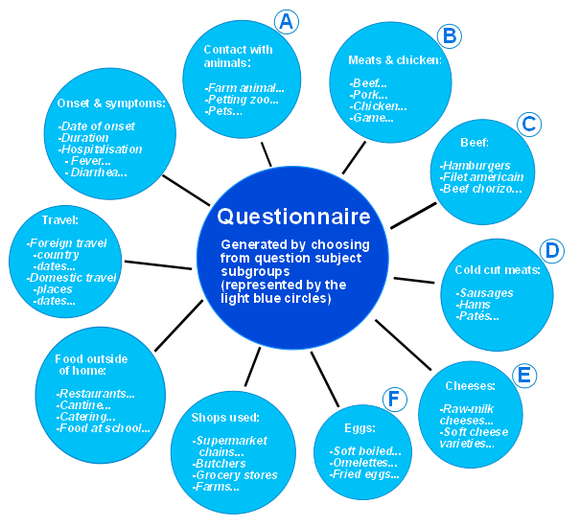
Figure 1. Conceptual framework of the principle of the question bank. A questionnaire for a given outbreak is produced though selection of groups of or individual questions from a large repository of questions. The organisation of these questions into different groups and levels, allow for easy generation of targeted questionnaires. The questions shown are examples only and not meant to be exhaustive, but to illustrate the concept.

Figure 1 also illustrates another level of separation of question groups. Some groups of questions will comprise basic patient information, demographic information, clinical information and so on. Such information may be coded as private and may, if so wished, in the subsequent EpiData analysis process be automatically excluded for datasets meant for sharing with other countries or ECDC.

Formulating an extensive list of questions applicable on and foreseeing a large amount of outbreaks caused by different agents and under different settings is a potentially very large task, that cannot be fully performed within the scope of this tender. We therefore propose to supply the framework and the questions that would be applicable to typical outbreaks with the agents known to have caused important outbreaks at the EU level, including: salmonella, campylobacter, STEC, listeria, Yersinia enterocolitica, shigella, Clostridium botulinum, brucella, hepatitis A, norovirus and trichinella. However, given the framework the list of specific questions may be further developed and maintained by others in the future. Please also note that details on the strategy for collection of data material for the questions is presented in section III.

B. Development of a modifiable question matrix
This is simply the database system in which the question bank is maintained. The database will be constructed in a form that can be understood by EpiData and its design will be kept as simple as possible. The question matrix will be made so that new questions can easily be added. Such questions will then be added to the question bank matrix and will preserve the unique coding in the following data entry and analysis steps in EpiData. The control of the database will be via EpiData (see below) and it is a possibility to create a data entry form in the software which will allow the user to add new questions. Instructions for users about how to modify the forms will be part of the EpiData Data Manager and as such directly available via the menu system.

Also this approach will allow for generation of questionnaires in other languages than English, should this be desired. The questions may be translated once and for all, and can be given a code signifying the language. The language of choice can then be chosen from the questionnaire generation tool.

Table 1 illustrates how the questions in the question bank can be organised in a simple tabular form to allow the questionnaire generating tool to function. Each question has a unique identifier, but is also coded as belonging to for instance the basic clinical information group or to the level 1 salmonella question group. Also language control is easily obtainable. The simplicity of this system makes is robust, transparent and easily modifiable.

Table 1 The schematic form of the question bank from which the questionnaire generating tool draws the data it uses
ID | Question | Level | Type | Salmo | Noro | STEC | Lang
12 | Which date did you have the first symtoms of your disease? | 1 | Clin | 1 | 1 | 1 | eng
41 | Did you travel to another country at the time you became ill, or in the 7 days before? | 1 | Travel | 1 | 1 | 1 | eng
77 | Did you, in the 5 days before you became ill, eat chicken? | 1 | Food | 1 | 0 | 2 | eng
77_1 | In which shop was this chicken bought? | 1 | Food | 1 | 0 | 2 | eng
182 | Did you, in the 3 days before you became ill eat any type of dessert with fresh or frozen berries? | 1 | Food | 0 | 1 | 0 | eng
565 | Did you, in the 5 days before you became ill, eat spreadable sausage containing oncooked pork meat (teewurst)? | 2 | Food | 1 | 0 | 0 | eng
99 | Do you sometimes drink unpasterized milk? | 1 | Drink | 2 | 0 | 1 | eng
99 | ¿A veces bebe usted leche sin pasteurizar? | 1 | Drink | 2 | 0 | 1 | esp

C. Questionnaire and data entry generating tool
This is a software application principle that will be developed using EpiData. We propose to construct an interface that will provide easy use and allow the user to generate questionnaires based on the collection of questions in the question bank. The user will be given a choice to construct questionnaires by mode (eg “suspected water borne outbreak”) or by disease. The tool will give the user the possibility to select from a list of the diseases that have previously caused outbreaks of EU importance, including: salmonellosis, campylobacteriosis, STEC/VTEC infection, listeriosis, yersiniosis, shigellosis, botulism, brucellosis, hepatitis A, norovirus infection and trichinellosis. The user will also be able to select the level of detail of the exposure questions. For instance, if there is already indications that a given salmonella outbreak might be caused by pork meat, additional groups of pork exposure questions can be selected by clicking at the interface. Importantly the user will also be able to add his or her own questions.

Necessary development of Software
The tool described needs to be developed as part of the re-writing of EpiData Software. Some aspects of this has been tested in the already released test application (as described in the supporting documentation), e.g. pasting on a graphical form and moving field objects (questions) around. User acceptability of the basic new principle has been attained by allowing for import of EpiData and Epi Info v6 files and also pasting of structures defined in the “QES” form known in current EpiData Entry.

Other aspects of the proposed parts are not developed yet, e.g. importing the question matrix or printing of forms as replicates of screen views (WYSIWIG principle). English will be the default language, but the system could be prepared for more languages. A requirement for internationalisation and local adaptation is the possibility of using local extensions in alphabets, e.g. “æøå” or “äà”. Since development of EpiData Software is based on open standards this calls for implementation of UTF-8 font capabilities. Another option could be to include multi-language questionnaires, such as described in some of the XML based standards (e.g. DDI-3.0 – see ddialliance.org). This will be explored as part of the development of these tasks.

Fallback solution
If development of the new XML structured database and EpiData Manager proves difficult or runs into unexpected problems a fallback solution will be to develop standardised questionnaires for the typical outbreak situations already known. This is known as the QES-CHK-REC file principle used for quite many years already. It is however anticipated (and technically the most favourably solution) that the work can be made after the new XML standards. Decisions of which route to follow will be taken at 31 August 2010 at the latest (milestone 5, section III).

Task 7
The objective of this task is to create a software for basic descriptive epidemiological analysis, i.e. construction of an epidemic curve and demographic distribution tools, such as a function to easily create a breakdown by age and gender. Again, the use of EpiData as the software of choice readily allows for this, as EpiData already have functions to perform most of these analysis. These functions will be tailored to the specific requirement of the toolbox.

As described above there is an interdependency between the principles of information (task 5), creation and implementation of the database structure (task 6) and the basic analysis in this task 7. When appropriate information has been collected basic analyses consist of: overview of case volume (number), case composition (sex and age groups and possibly other demographic variables such as location and occupation), frequency of exposures, time patterns of the outbreak and proportions of cases among the exposures. The software tools developed should be focused on these types of analysis.

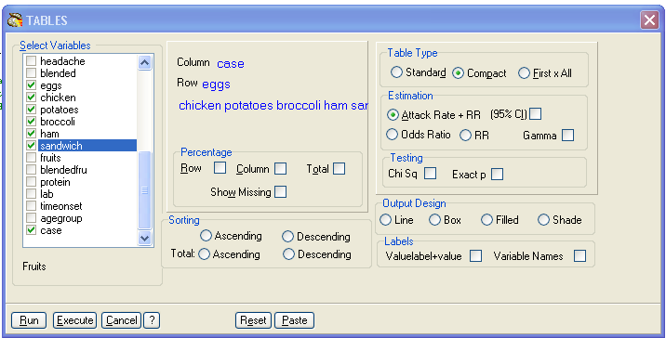
Figure 2. Example of a dialog box for easy user creation of tables already implemented in EpiData software.

As part of the development in tasks 6-8, a uniform smooth working procedure will be described. Analysis will be extended based on a dialogue principle, where users can easily see how to select the variables they wish to analyse (see Figure 2).

The idea is that the “route” for the staff from collecting data to first draft analysis should be as short as possible. When the user hits the “execute” button, a final table is readily produced. At the same time scripts are recorded, such that standard types of reporting can be specified. This could be added into a number of standard reports. Figure 3 shows an example of a epidemic curve made using the existing EpiData analysis software. In this example the cases shown in the epidemic curve are stratified by gender, using red/blue colouring. This illustrates the power already contained within EpiData. See also the details of EpiData functionality given under task 8.

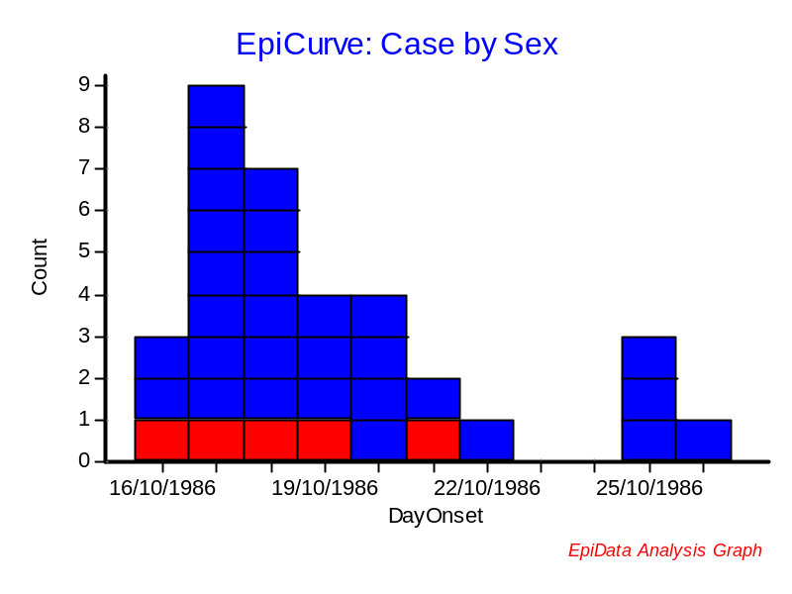
Figure 3. Epidemic curve made by existing EpiData software.

In addition to the mentioned possibilities above task 7 will also provide the possibility of exploring other basic descriptive analysis aspects. Examples of this are creation of scatter and box plots and different types of tabulations and standard reports. This will help the user to, very easily, create professionally structured outbreak or situation reports. The development so far of the EpiData Analysis software clearly shows that this is attainable, but also that additional development and extension is needed for certain aspects.

Task 8

The objectives here are to consider when it will be feasible to use analytical epidemiological studies in a situation of a FWD outbreak. We propose to write down simple guidelines giving advice on this subject. Conduction of analytical studies, however, also poses the requirement for more advanced data analysis. In our experience, this may often be prohibitive for investigators that are not trained epidemiologists, e.g. food safety professionals or other professionals that may carry out for instance a questionnaire study that may be analysed as a cohort study. In addition we therefore propose to further explore, how we may be able to develop EpiData to suit the needs for such analysis, focusing primarily on cohort and case-control analyses.

Table 2. Standard food exposure table for a cohort study, created in EpiData
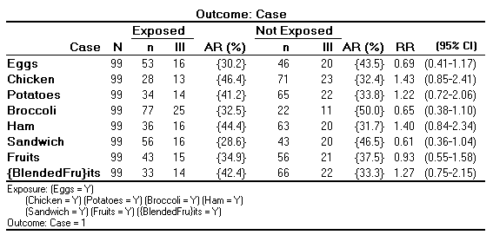

Preparation of overview tables for the identification of overall exposure patterns can give a quick overview of whether there seems to be a single causal agent or a broader picture. Table 2 shows an example of the creation of such a table, a table that is not readily constructed using large professional (and expensive) software packages. Notice how confidence intervals are included based on proper methodology (Robins, Greenland for RR) and how outcome and exposure definitions are given in the footer of the table. Concise outbreak tables can give the field epidemiologist a good indication of the outbreak situation at an early stage of the analysis. The exact form of the standard tables can be adapted following discussions with the expert panels as part of the tender.

Also tools for more complex statistical analyses can be used in the outbreak situation, an example of which may be seen in Table 3.

Table 3. Example of a sophisticated adjusted analysis performed using existing EpiData software.
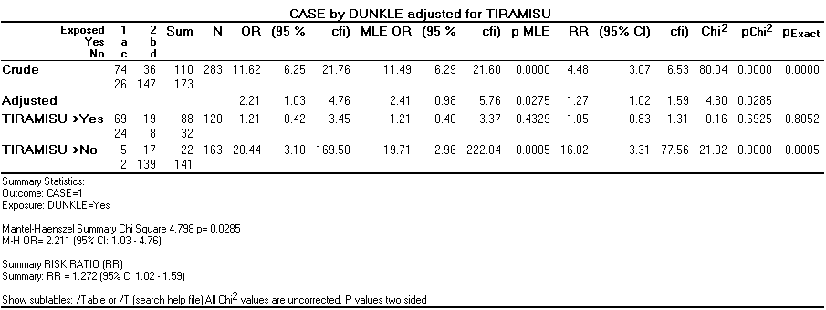

Task 9

Epidemiological methods, as covered in the previous four tasks, are obviously central tools in most outbreak investigations, however, environmental, microbiological or molecular epidemiological investigation methods are often also applicable and outbreak investigations are generally more successful and give more convincing evidence when all approaches are applied in parallel. Furthermore, detection of organisms in patients and comparisons of isolates are often a prerequisite for establishing that an international outbreak is taking place.

Following considerations on the subject, we propose to make one or more documents giving advice on how to incorporate environmental and microbiological approaches into different sets of typical outbreak investigation, with focus on the agents most often giving rise to outbreaks, i.e. salmonella, norovirus, STEC, shigella and campylobacter. These documents may be used for the ECDC as a guideline when faced with the coordination of multi-state outbreaks or they may be used directly by outbreak investigators in member states. The documents may take the form of Guidance documents or recommendations.

Subjects covered under this task may include recommendations on: collecting and storing microbiological isolates for future comparative analysis; methods for detection of agents in food and water and typing methods. The latter issue should be seen in the context of the expertise and capacity present in member states. For bacterial isolates of foodborne disease most national typing centres for human disease will use phage typing or perform PFGE, though other molecular typing methods are also used, especially MLVA and different kinds of sequence based methods. And a questionnaire carried out by EFSA in 2008 among food/veterinary laboratories showed that 20 member states out of 26 that responded, perform molecular typing of salmonella and STEC isolates and that 15 type listeria isolates from food, animals and feedstuffs (EFSA Journal (2009) 272, 1-52). Standardisation of methods and incorporation of measures to ensure comparability of results may therefore become a very important point in the work with this task. Members of the project team are international recognised experts on these matters and one project participant, Eva Møller Nielsen, have very recently concluded work performed for ECDC on these matters, under the tender contract: “Technical specifications for a molecular typing database with special focus on PFGE data”.

Environmental investigations, including tracing of food products and risk assessments are important parts of the investigation, as it may indicate where cases may occur and which products are more likely to be involved. These investigations often involve the food safety authorities and the international organisations involved in food safety.

Task 10
The objective in this task is to create a schematic overview of information flow in the international alert systems involved in foodborne outbreaks with an international component. At the moment there are several international alert systems (including INFOSAN, WHO IHR, RASFF, EWRS and EPIS / ECDC FWD network), covering the veterinary and food sectors and the public health sector, both on regional and global level. To improve collaboration and a coordinated approach, it is necessary to know how and when information is communicated in these systems, so that both the member states and the international organisations can ensure that those who need to know are informed in a timely and correct manner. This has been illustrated in several outbreaks during the last years, where outbreaks caused by food imported from countries outside the EU emphasized the need for clear and coordinated information flow in the different sectors (see example in Figure 4)

To achieve this objective, a schematic overview will be made including all alert systems involved, both in the veterinary and food sector, and the public health sector. This will be drafted in collaboration with representatives of the relevant systems, and will take into account comments and issues raised during the planned case-study on international alert systems to be conducted by ECDC-FWD during the 2010 FWD-network annual meeting.

The draft will be linked up with the alert systems homepages where description of the different systems, reporting requirements and contact information is provided. If so whished by the ECDC, this information made also be made as a web-page that could be available at the ECDC website.

Several of these systems are considered confidential, and for some systems, part of the information is confidential and part public (i.e RASFF). These issues need to be clearly described in the overview. How to take these confidentiality issues into account will also be discussed during the drafting process.

After the first drafting process with the representatives for the alert systems, the draft will be distributed to the relevant national contact points for the alert systems in order to get feedback and comments.

Figure 4 presents a schematic overview of the alert systems as presented during the annual FWD-network meeting in 2009.
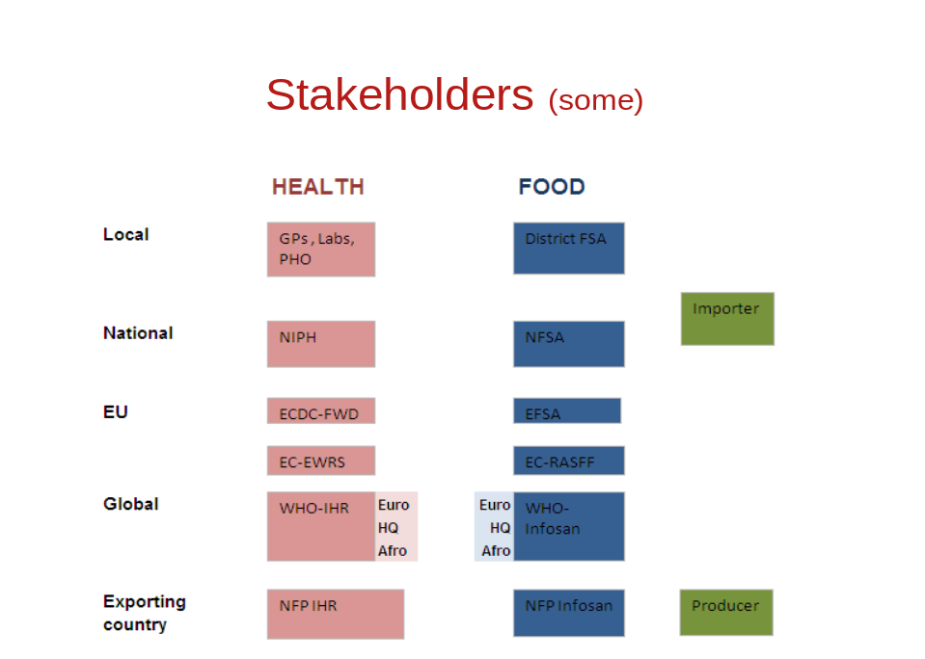
a.
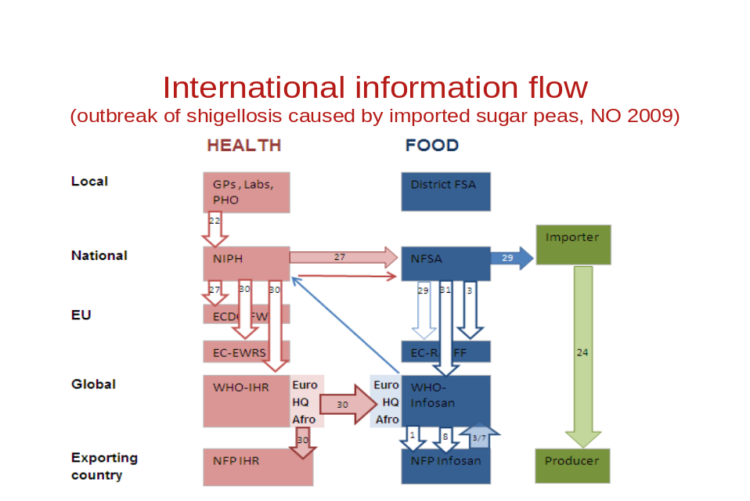
b.
Figure 4. A: Overview international alert systems with foodborne incidents. B: Example of information flow during an outbreak of shigellosis caused by imported sugar peas, NO 2009 (presented by K. Nygård at FWD annual meeting 2009)

Brief description of some stakeholders in the EU Member States and EFTA/EEA countries as presented in the above figure:
Local and national stakeholders in the MS:
- Regional public health officers(PHO) and national public health institutes (NIPH), environmental and/or food safety authorities (FSA) who are responsible for investigating outbreaks and investigating premises;
- Regional and national veterinary authorities concerned with zoonoses due to animal exposure.
European and other international public health organisations and networks working with food safety incidents:
- ECDC-FWD
The programme on food- and water-borne diseases and zoonoses (FWD) at ECDC was set up in 2006, and covers all the most common fooodborne infections. One of the objectives of the FWD programme is to improve early detection and coordinated response to FWD outbreaks with an EU dimension and to facilitate cooperation between public health, veterinary and food safety sectors. Several clusters or outbreaks of FWD have been identified through the FWD network of urgent inquiries, and in 2010 ECDC launched an informal platform (EPIS) to facuilitate exchange of information and sending out urgent inquiries.
- EWRS
EWRS is a web-based system linking the Commission, the public health authorities in Member States and EEA countries responsible for measures to control communicable diseases and the European Centre for Disease Prevention and Control (ECDC). Decision 2119/98/EC 2000/57/EC regulate the procedure for reporting and for the functioning of the system. Under these decisions, Member States should inform about events likely to affect public health at the EU-level. Therefore, the EWRS is frequently used for notification of outbreaks, exchange of information and discussion about the coordination of measures among players.
- WHO – IHR
The revised international health regulations [IHR(2005)] play an important role in preparedness and response for outbreaks with an international dimension. It specifies criteria for which events need to be notified by the designated national IHR focal points, including foodborne outbreaks.
European and other international veterinary and food organisations and networks working with food safety incidents:
- Rapid Alert System for Food and Feed (RASFF)
The European Commission coordinates the Rapid Alert System for Food and Feed (RASFF). This is a system for rapid information exchange between food and feed competent authorities in the MS in case a risk for human health has been identified in food or feed. The alerts are made public available in a short version at their web-site
- European Food Safety Authority (EFSA)
The European Food Safety Authority (EFSA) provides EU risk assessment regarding food and feed safety. It provides also with independent scientific advice and communication on existing and emerging risks in food and feed products. Does not have a specified alert function, but can be involved in doing risk assessments for an incident.
- International Food Safety Authorities Network (INFOSAN)
INFOSAN is an International Food Safety Authorities Network co-ordinated bythe World Health Organization (WHO), which functions as an information network for the dissemination of important data about food safety issues. INFOSAN Emergency is specifically dedicated to identification, assessment and management of food safety events of possible international concern. Collaborating closely with countries, alerts may be developed and disseminated to the INFOSAN emergency network. To help respond to country requests for assistance during food safety emergencies. INFOSAN Emergency partners with the Global Outbreak Alert and Response Network (GOARN).

Task 11

At present, a lot of experience is gained in different countries on investigation and management of FWD outbreaks involving more than one country within the EU. Some of the outbreaks are published in peer-reviewed journals, however much of the material used in the investigation is not readily available, such as protocols, questionnaires and evaluation reports. Additionally, some national outbreaks with a high public health impact have in retrospect been evaluated by external experts, with recommendations and lessons learned that can be of use for other countries.
The objectives of this task is to develop a repository of such resource material for investigation and management of FWD outbreaks, with emphasis on outbreaks at the EU level. The repository should include
a. Protocols for investigations which have been carried out for FWD outbreaks with an EU level component (from any country, in any language).
b. Reports of ‘model’ FWD outbreak investigations with an EU component (from any country in any language).
c. Lessons learnt from FWD outbreak investigations with an EU component (from any country in any language). An example would be a very large outbreak that occurred in Denmark in 2008 and where Karin Nygård was part of the official evaluation committee, examining the methodology following the outbreak.
d. Key guidance documents from internationally recognized sources (e.g. WHO, CDC) for the investigation of FWD origin outbreaks.
e. Literature and scientific articles of key importance to the investigation of FWD outbreaks with a focus on the six priority FWDs for ECDC.

The repository would be used internally at ECDC and made available to the FWD network that is coordinated through ECDC.

To obtain this material, a request will be sent to the FWD network members and the EPIET/EAN network asking if they are willing to make these documents available in a repository based on the ECDC. Separately, a search will be conducted to identify material already available on the www and in the published literature.

We suggest making a searchable database for the repository, with standard fields describing the documents, and with the uploaded documents. The database will be made available for ECDC, and development of a web-based repository should be done in collaboration with the ECDC technical department. To improve functionality and to keep the documents updated and relevant, an upload function for external users should be considered and discussed.

Table 4 Example of possible fields to be included in the document repository for outbreak resource documents
Document type | Language | Agent | Food | Com-ment | www-link | Uploaded document | Reference
Protocol | NO |  |  |  | Not public | Outbreak-protocol.doc | -
Report | NO | Shigella | Produce |  | Not public | Shigella-outbreak-report-2009.doc | -
Article | EN | Salmo-nella | Produce |  | http://www.eurosurveillance.org/ViewArticle.aspx?ArticleId=3321 | Eurosurv-emberland.pdf | Emberland KE et al. Euro Surveill. 2007;12(48):pii=3321.
Evaluation | NO | EHEC | Meat | English summary | http://www.regjeringen.no/upload/kilde/lmd/prm/2006/0025/ddd/pdfv/301838-e-coli-rapport-151206.pdf | 301838-e-coli-rapport-151206.pdf | No
Question-naire | EN | - | - | Phone ques. Assess dose response | http://www.foodrisk.org/exclusives/FDOQ/ | cdph-phone-ques-EN.doc | No
Question-naire | ES | - | - | Phone ques. Assess dose response | http://www.foodrisk.org/exclusives/FDOQ/ | cdph-phone-ques-ES.doc | No

Section III. Project management, time and evaluation procedures

Project group

The project group consists of the following eigth persons. From the SSI: Steen Ethelberg, Kåre Mølbak, Eva Møller Nielsen and Luise Müller. From the FHI: Karin Nygård, Preben Aavitsland, Georg Kapperud and Line Vold. In addition EpiData will be involved in the completion of three of the tasks. From EpiData there are two participants: Jens Lauritsen and Thorsten Christiansen. Steen Ethelberg and Karin Nygård will be responsible for the project management. Kåre Mølbak and Preben Aavitsland will constitute a supervisory group and be financially responsible for the SSI and FHI respectively.

Role of each participant

Steen Ethelberg and Karin Nygård will be the principal project participants. They will manage the project and be involved in the actual work of all tasks. Steen Ethelberg will be the main responsible person for communication between the consortium and the ECDC. For the completion of the non-IT epidemiological tasks they will be assisted in developing the task deliverables by epidemiologists Line Vold and Luise Müller. The two state epidemiologists, Kåre Mølbak and Preben Aavitsland, will supply input on all tasks and evaluate them before hand-over to ECDC. The laboratory and typing perspective on the task development will be provided by Eva Møller Nielsen and Georg Kapperud. Three tasks involve IT-development (tasks 6-8). These three tasks will be performed by Jens Lauritsen and Torsten Christiansen from EpiData. EpiData is the major (if not in reality only) existing free software, developed with targeted analysis tools for field epidemiology and outbreak investigations. By having the EpiData developers as direct participants in the project, it is possible to develop tailored solutions that will be easy to use and will be freely available to everyone working on FWD in Europe (and other countries too). We also note that according to the licensing system of EpiData its use in larger projects carries an obligation to assist in the funding of the development (this is why the program can be downloaded at no cost) and that the current revision of the system (changing its underlying data structure and reprogramming all modules) will have as a consequence that developments by other research groups relying on the current EpiData principle will not be functional under the new system. By working with the modernised principles of the underlying technology, sustainability of the developed solution is maximised. In particular since the rewriting (once fully financed) will result in release of the software under an open-source license.

Table 5 gives an overview of all participants and their roles in the project. More details on each participant may be found in the 10 CV’s and in the selection criteria documents, included as part of envelope C.

External group of professional advisors
The project deliverables are of use for the ECDC and should therefore of course be developed in a process with frequent communication with the ECDC. However, the project deliverables will also be of major use to epidemiologists and microbiologists working with FWD outbreaks in EU member states.

Table 5 Project team, consortium and sub-contractor members
Name | Institution,  Department | Current job function | Role in project | Particular involve-ment in tasks no.
Steen Ethelberg, M.Sc. (Biology), Ph.D. | SSI, Dept of  Epidemiology & Dept of Microbio Surveillance and Research | Head of Outbreak Centre, senior scientist | Leader, management of project, involved in development of all tasks | All*
Karin Nygård, DVM, Ph.D. completed EPIET | FHI, Dept of Epidemiology | Head of Outbreak Centre, senior scientist | Co-leader, management of project, involved in development of all tasks | All*
Kåre Mølbak, MD, DMSc | SSI, Dept of  Epidemiology | Consultant, Director,  Head of Dept of Epi, State Epidemiologist | Supervise entire project, input on all tasks | 5, 11
Eva Møller Nielsen, M.Sc.  (Food Science & Tech), Ph.D. | SSI, Dept of Microbio Surv and Res | Head of section of molecular typing | Microbiology/typing issues | 9, 11
Luise Müller, M.Sc. (Public Health), completed EPIET | SSI, Dept of  Epidemiology | Staff epidemiologist, member of Outbreak Centre | Co-develop several of the strictly epidemiological tasks | 3, 4, 9
Preben Aavitsland, MD | FHI, Dept of Epidemiology | Consultant, Director,  Head of Dept of Epi, State Epidemiologist | Supervise entire project, input on all tasks | 10
Georg Kapperud, Cand. Real, Ph.D. | FHI, Dept of Foodborne Infections | Professor, head of section | Molecular epidemiology issues | 9
Line Vold, DVM, completed EPIET | FHI, Dept of Epidemiology | Senior epidemiologist, member of Outbreak Centre | Co-develop several of the strictly epidemiological tasks | 1, 2, 3, 4
Jens Lauritsen, MD, Ph.D. | Odense University Hospital, University of Southern Denmark. and the EpiData Association, Odense Denmark | Leader of EPIDATA, Consultant, Associate professor, | Develop, structure and specify the software tasks | 6, 7, 8
Thorsten Christiansen, M.Sc. (computer science) | Odense University Hospital, University of Southern Denmark. and the EpiData Association, Odense Denmark | IT-developer | Develop the software tasks, program the code | 6, 7, 8
* Tasks 6-8 will be carried out by the EpiData Group, but the project leader and co-leader will be the prime discussants during the development.

For this reason the consortium plans to consult the entire FWD network to get input and advice as to the needs of the individual countries. This may be said to be particularly important as the consortium consists of scientist from two countries only, although the network experience of the consortium members should ensure that they are in touch with which problems are faced in different countries.

Additionally, the consortium proposes to establish a small group of external advisors consisting of scientist working with foodborne outbreaks as part of their daily work. In the process of preparing this application, the consortium has been in touch with selected scientist from England, the Netherlands, and Hungary who have agreed to be part of such a group of external advisors. Moreover, we know through informal contacts with different institutes in Europe, that several scientists with a good knowledge of outbreak investigations techniques, would be interested in joining such a group and we do not see the formation of such a group as a potential problem to the project. We also aim to approach EPIET and FETP networks, as they will be important users of the toolbox.

These groups will be consulted during the development of the tools that are directly relevant to member states users. This would in particular include the software solutions. The external advisors would get the possibility to try out the software for a period of time and report on their experiences. Contact would be kept through email and by telephone. A milestone (see table below) is planned for December 2010, for a final evaluation report of the software solutions. This will give time to correct the software before final hand-over to ECDC.

The development of Task no 5 will also require guidance from external experts, as it involves the development of a large number of questions used for trawling questionnaires. This work will be based on existing trawling questionnaires and developed further from these. Initially in the process of the Task no. 5 workflow, the FWD network will be contacted and asked to supply existing trawling questionnaires. Based on informal contact with public health institutes from this consortium and other tender applicants, we foresee that members of the FWD network will be happy to cooperate on this. It should also be said, that both the FHI and the SSI have conducted projects in recent years with the aim of improving their own trawling questionnaires. As part of this process trawling questionnaires on several diseases used in several other European countries plus the US and Canada have been collected. Expertise with trawling questionnaires and a small collection of such is thus already present within the consortium. Both SSI and FHI would still like to develop their trawling questionnaires even further and both hope to profit on the development of this project (this said to show that there is also keen interest in the outcomes of the project from our own side).

Lastly, it never harms to look beyond Europe. A visit to the central outbreak investigation team at the Centers for Disease Control (CDC) in Atlanta have been planned for in May 2010 by Karin Nygård. A one-week visit to the Minnesota Department of Health (MDH) have been planned for in October 2010 by Steen Ethelberg. Minnesota is renowned for their handling of gastrointestinal disease outbreaks; all salmonella cases are routinely interviewed with a trawling questionnaire using an iterative questionnaire technique that may also be of relevance in Europe. Both CDC and MDH would be willing to assist and supply questionnaires and similar material for this project.

Deliverables, project timeline

The methodology proposed for the completion of each task is described in section II. Each task will constitute a project deliverable. Additionally, the project plan specifies three further deliverables: Deliverable 12 is the meeting report specifying the required changes to the outcomes of the 11 tasks, which will be decided on at the post 9-month evaluation meeting. Deliverable 13 is a guidance document with the purpose of instructing the users in the use of each of the 11 tools. This document may also in part take the form of Internet applicable material and/or may contain a draft user web-interface where content can be managed by the ECDC. Deliverable 14 is the complete package containing the completed 11 tools and the guidance document. Table 6 lists all deliverables, their expected outcomes, their individual workpackage (or task) periods and the date they should be delivered to the ECDC. Figure 5 shows a timeline (Gantt) diagram, illustrating the allocated time periods for each workpackage (task).

In the second week (proposed) after the delivery of the draft toolbox to ECDC, we will organize a one-day meeting at the SSI premises, with the purpose of reviewing the entire draft toolbox and guidance document. To this meeting will be invited at least two persons from the ECDC FWD programme and five members of the FWD network coordination group. The travel costs related to the ECDC staff will be borne by ECDC, whereas the travel cost of the members of the FWD network coordination group will be paid for by the consortium. The members of the coordination group will be invited upon agreement with the ECDC project manager and will include persons that are representative of all EU countries, but also of epidemiology and microbiology expertise. Before the meeting, we will prepare an agenda in cooperation with the ECDC and discuss the content of the meeting with the ECDC. The agenda of this meeting will be drafted by the contractor and agreed with ECDC beforehand. As the outcome of the meeting, we will make meeting minutes and a list of the specific parts of the toolbox tools that need to be revisited and improved by us before the final hand-over to the ECDC of the completed toolbox.

Table 6. Overview of project deliverables
Deliverable name | Deliverable id | Deliverable format | Time period | Date of hand-over to ECDC
Criteria for the investigation | 1 (Task 1) | Document | 09/Aug/10 – 01/Oct/10 | 30 Nov 2010
Checklist for teleconference | 2 (Task 2) | Checklist | 09/Aug/10 – 24/Sep/10 | 30 Nov 2010
Case definitions | 3 (Task 3) | Guidance Document | 16/Aug/10 – 15/Oct/10 | 30 Nov 2010
Recommendations for case finding | 4 (Task 4) | Recommendations | 30/Aug/10 – 12/Nov/10 | 30 Nov 2010
Trawling questionnaire resource | 5 (Task 5) | Software, Documents | 07/Jun/10 – 28/Jan/11 | 28 Feb 2011
Software for database data entry | 6 (Task 6) | Software, Documents | 06/Jul/10 – 26/Nov/10 | 28 Feb 2011
Software for data analysis | 7 (Task 7) | Software, Documents | 06/Sep/10 – 26/Nov/10 | 28 Feb 2011
Solution for analytical studies | 8 (Task 8) | Software, Documents | 06/Sep/10 – 28/Jan/11 | 28 Feb 2011
Considerations for environmental and microbiological studies | 9 (Task 9) | Report | 09/Aug/10 – 12/Nov/10 | 30 Nov 2010
Communication scheme, international stakeholders | 10 (Task 10) | Report | 30/Aug/10 – 29/Oct/10 | 30 Nov 2010
Repository of resource material | 11 (Task 11) | Database (web-content) | 30/Aug/10 – 26/Feb/11 | 28 Feb 2011
Meeting minutes specifying changes | 12 | Meeting report | 8/Mar/11 – 31/Mar/11 | 01 May 2011
Supporting documentation | 13 | Document, or web doc | 07/Jun/10 – 30/May/11 | 01 Jun 2011
All above deliverables, corrected | 14 | Report, software, web material etc (hard copy and electronic format) | 25/Mar/11 – 30/May/11 | 01 Jun 2011

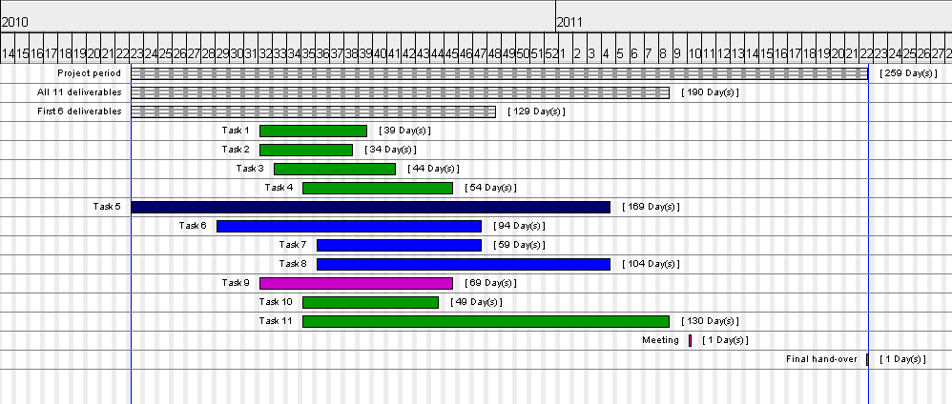
Figure 5. Gantt chart showing the timelines for each of the 11 tasks, the evaluation meeting and the final hand-over. Task 5, which is central to the project, is shown in black; tasks 6-8 that are primarily IT projects are shown in blue and task 9, which has a major microbiological component is shown in violet.

Monitoring plan, milestones

To be able to monitor the project progress over the period, regular meetings between the project leaders have been planned. As an outcome of these meetings, brief project review reports will be produced. These simply aim to monitor the progress of each of the workpackages.

Because the project management is a small team, consisting of just two persons, and because the project management are also performing the majority of the work themselves, the project is not anticipated to be at risk of extending the time frame. However, to be sure of this, the project supervisory group (Kåre Mølbak and Preben Aavitsland) will also follow the project progress and receive the project review reports.

All tools except tools 6-8 will be drafted by Steen Ethelberg and Karin Nygård with the additional participation of other project members as described in Table 5. Steen Ethelberg and Karin Nygård will also be closely involved in the conceptual planning and testing of tools 6-8. All tool drafts will be reviewed by the entire consortium. During the drafting and reviewing process, all documents will be available in electronic format at a shared electronic platform (Dropbox or similar document sharing tool).

To assist in the monitoration of the project progress a series of milestones have been formulated. These are presented in Table 7 below.

In addition to the project leader meetings (milestones 2, 6, 8 and 12), a number of other project milestones have been set. It is hoped and very much expected that the software development will be performed according to the XML version of EpiData. However, should this fail, development will be according to the existing versions. A decision on if XML or the existing coding language should be used shall be taken at the end of August (milestone 7). The tools that take the form of documents and related material (ie all tools except tool 5-8) will be presented to the FDW network (either all members or a select group) and their comments invoked before the final hand-over to ECDC (milestone 9). The initial EpiData software solutions ready in the autumn of 2010 will be presented to the group of external experts. The final feedback shall be ready medio December 2010 (milestone 11).

Table 7. Overview of project milestones
Mile-stone no. | Milestone | Completion date | Comments
1 | Sign contract | 4 June 2010 | Project period begins
2 | Kick-off meeting, project leaders | 10 June 2010 | In conjunction with Nordic Zoonosis Centre meeting, Iceland
3 | Presentation of the project to FWD network participants | 22-23 June 2010 | Coinciding with the FWD meeting in Dublin
4 | Group of external experts established | 22-23 June 2010 | Coinciding with the FWD meeting in Dublin
5 | Collection of existing questionnaires from MS | 15 July 2010 | Via the FWD network
6 | Project status meeting, project leaders | 18 Aug 2010 | May be held as series of tele meetings
7 | Decision on version of EpiData | 31 Aug 2010 | Develop the tools in new (XML) or present generation of EpiData
8 | Project status meeting, project leaders | 01 Nov 2010 | May be held as a series of tele meetings
9 | Review of written tools by FWD network members | 15 Nov 2011 | Network members will be email the task outcomes for initial commenting
10 | Delivery of 6 first tools | 30 Nov 2010 | Tasks 1,2,3,4,9 and 10
11 | Input from external evaluaters on the questionnaire and IT components | 15 Dec 2010 | Final reports from group of external experts from EU public health institutes on questionnaire and database system
12 | Project status meeting, project leaders | 31 Jan 2011 | May be held as a series of tele meetings
13 | Delivery of 5 remaining tools | 28 Feb 2011 | Tasks 5,6,7,8 and 11
14 | Meeting with ECDC and 5 invited experts | 8 March 2011 | Proposed date
15 | Consultation with ECDC | 15 Apr 2011 | Clarification on precise form of changes to tools, if required
16 | Final hand over | 1 June 2011 | End of project

Westrell T, Dusch V, Ethelberg S, Harris J, Hjertqvist M, Jourdan-da Silva N, Koller A, Lenglet A, Lisby M, Vold L. Norovirus outbreaks linked to oyster consumption in the United Kingdom, Norway, France, Sweden and Denmark, 2010. Euro Surveill. 2010 Mar 25;15(12).
Ethelberg S, Lisby M, Bottiger B, Schultz AC, Villif A, Jensen T, Olsen KE, Scheutz F, Kjelso C, Muller L. Outbreaks of gastroenteritis linked to lettuce, Denmark, January 2010. Euro Surveill. 2010 Feb 11;15(6). pii: 19484.
Heier BT, Nygard K, Kapperud G, Lindstedt BA, Johannessen GS, Blekkan H. Shigella sonnei infections in Norway associated with sugar peas, May-June 2009. Euro Surveill. 2009 Jun 18;14(24). pii: 19243.
Muller L, Jensen T, Petersen RF, Mølbak K, Ethelberg S. Imported fresh sugar peas as suspected source of an outbreak of Shigella sonnei in Denmark, April-May 2009. Euro Surveill. 2009 Jun 18;14(24). pii: 19241
Bruun T, Sørensen G, Forshell LP, Jensen T, Nygard K, Kapperud G, Lindstedt BA, Berglund T, Wingstrand A, Petersen RF, Müller L, Kjelsø C, Ivarsson S, Hjertqvist M, Löfdahl S, Ethelberg S. An outbreak of Salmonella Typhimurium infections in Denmark, Norway and Sweden, 2008. Euro Surveill. 2009 Mar 12;14(10). pii: 19147
Lewis HC, Ethelberg S, Olsen KE, Nielsen EM, Lisby M, Madsen SB, Boel J, Stafford R, Kirk M, Smith HV, Tikumrum S, Wisetrojana A, Bangtrakulnonth A, Vithayarungruangsri J, Siriarayaporn P, Ungchusak K, Bishop J, Mølbak K. Outbreaks of Shigella sonnei infections in Denmark and Australia linked to consumption of imported raw baby corn. Epidemiol Infect. 2009 Mar;137(3):326-34.
Pezzoli L, Elson R, Little CL, Yip H, Fisher I, Yishai R, Anis E, Valinsky L, Biggerstaff M, Patel N, Mather H, Brown DJ, Coia JE, van Pelt W, Nielsen EM, Ethelberg S, de Pinna E, Hampton MD, Peters T, Threlfall J. Packed with Salmonella--investigation of an international outbreak of Salmonella Senftenberg infection linked to contamination of prepacked basil in 2007. Foodborne Pathog Dis. 2008 Oct;5(5):661-8.
Emberland KE, Ethelberg S, Kuusi M, Vold L, Jensvoll L, Lindstedt BA, Nygard K, Kjelsø C, Torpdahl M, Sørensen G, Jensen T, Lukinmaa S, Niskanen T, Kapperud G. Outbreak of Salmonella Weltevreden infections in Norway, Denmark and Finland associated with alfalfa sprouts, July-October 2007. Euro Surveill. 2007 Nov 29;12(11):E071129.4.
: Denny J, Threlfall J, Takkinen J, Lofdahl S, Westrell T, Varela C, Adak B, Boxall N, Ethelberg S, Torpdahl M, Straetemans M, van Pelt W. Multinational Salmonella Paratyphi B variant Java (Salmonella Java) outbreak, August - December 2007. Euro Surveill. 2007 Dec 20;12(12):E071220.2
Nygård K, Lindstedt BA, Wahl W, Jensvoll L, Kjelsø C, Mølbak K, Torpdahl M, Kapperud G. Outbreak of Salmonella Typhimurium infection traced to imported cured sausage using MLVA-subtyping. Euro Surveill. 2007 Mar 15;12(3):E070315.5.
Coia J, Cormican M, Ethelberg S, Fisher I, Hernandez Pezzi G, Hjertqvist M, McKeown P, Nygard K, Smith-Palmer A, Soler P, Ward L. Outbreak of Salmonella Goldcoast affecting tourists exposed in Majorca from the UK, Ireland, Sweden, Norway and Denmark. Euro Surveill. 2005 Oct 27;10(10):E051027.3
Nygård K, Lassen J, Vold L, Andersson Y, Fisher I, Löfdahl S, Threlfall J, Luzzi I, Peters T, Hampton M, Torpdahl M, Kapperud G, Aavitsland P. Outbreak of Salmonella Thompson infections linked to imported rucola lettuce. Foodborne Pathog Dis. 2008 Apr;5(2):165-73.
Guerin PJ, Nygard K, Siitonen A, Vold L, Kuusi M, de Jong B, Rottingen JA, Alvseike O, Olsson A, Lassen J, Andersson Y, Aavitsland P. Emerging Salmonella Enteritidis anaerogenic phage type 14b: outbreak in Norwegian, Swedish and Finnish travellers returning from Greece. Euro Surveill. 2006;11(2):61-6.
Werber D, Dreesman J, Feil F, van Treeck U, Fell G, Ethelberg S, Hauri AM, Roggentin P, Prager R, Fisher IS, Behnke SC, Bartelt E, Weise E, Ellis A, Siitonen A, Andersson Y, Tschäpe H, Kramer MH, Ammon A. International outbreak of Salmonella Oranienburg due to German chocolate. BMC Infect Dis. 2005 Feb 3;5(1):7.
Available from: www.who.int/ihr/9789241596664/en/index.html
Available from: www.cifor.us/documents/CIFORGuidelinesforFoodborneDiseaseOutbreakResponse.pdf
https://webgate.ec.europa.eu/rasff-window/portal/
http://www.who.int/foodsafety/fs_management/infosan/en/index.html
Ethelberg S, Eurosurveillance. 2008;13(44), available from: www.eurosurveillance.org/ViewArticle.aspx?ArticleId=19023

